

SMARTCARD PHOTO IDENTIFICATION

APPLICANT  NAME: |  | DATE OF  BIRTH:
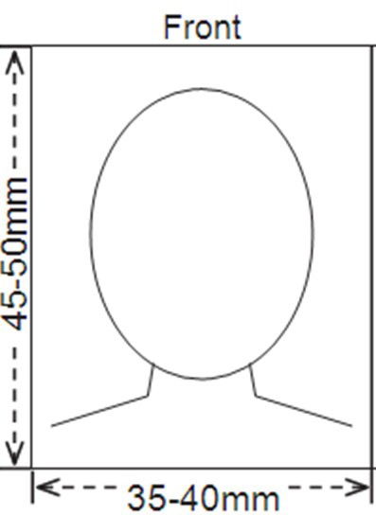

The photograph must:

- Be in colour
- Be no more than six months old
- Be passport size, which is 45-50mm high and 35-40mm wide
- If printing a hard copy photograph, it must be printed on photo-quality paper without visible pixels or dot patterns
- Have plain, light coloured background
- Show applicant’s head and top of shoulders
- Show the applicant looking directly at the camera with eyes open (if possible)
- Show the applicant with his/her hat and sunglasses removed
- A high-resolution colour photo can be taken by a mobile phone and emailed with your application

If attaching the photo to this form, please use a paperclip only, DO NOT pin, staple or glue your photograph to this form.

Privacy Statement: Information collected by the ACT Revenue Office (ACTRO) is protected by secrecy provisions contained in Acts administered by ACTRO and is used for the purposes of administering those Acts. In addition, personal information and personal health information provided to ACTRO is protected by the Information Privacy Act 2014 and the Health Records (Privacy and Access) Act 1997 , respectively. Information (including personal information) is not disclosed to any third party without the consent of the person involved, unless authorised by law.
Please go to our website www.revenue.act.gov.au to read or print out a copy of our privacy policy which sets out how personal information is collected, used and disclosed by the Commissioner for ACT Revenue and the ACT Revenue Office, how you may access and seek correction of your personal information, and how you may complain about breaches of privacy.

1

