2014 Client Survey
The ACT Revenue Office (ACTRO) conducted a survey from 17 October 2014 to 16 December 2014 as part of its commitment to maintaining and improving its customer service as well as its website.

The survey was available on the ACTRO website and as a hard copy at the ACTRO Customer Services Counter. Regular clients at the ACT Revenue Office Customer Services Counter were encouraged to respond. On the website the survey was announced as a News item on 17 October 2014. Another news item on 5 December 2014 reminded clients about the survey. Both News items were sent to all Revenue Office website subscribers.

The survey was also advertised on the:
- Timetotalkwebsiteathttp://www.timetotalk.act.gov.au; and
- ACT Government portal as a hot topic athttp://www.act.gov.au.

There were 75 online responses and 20 hardcopy responses for 2014 compared to 65 online and 7 hardcopy for the 2013 survey.
Customer service – level of satisfaction
Customer Service | Satisfied or very satisfied
 | 2013 | 2014 | change
Service quality | 69% | 75% | 6%
Accessibility of services | 77% | 70% | 7%
Service time in relation to service standards | 76% | 73% | 3%
Fairness of treatment | 77% | 78% | 1%
Information and advice is complete | 74% | 73% | 1%
Information and advice is reliable | 82% | 74% | 8%
Information and advice is consistent | 74% | 71% | 3%
Information and advice is clear | 78% | 69% | 9%
Staff knowledge and competency | 79% | 77% | 2%
Staff helpfulness | 84% | 80% | 4%
Information and advice fulfilled your needs | 78% | 70% | 8%
Accountability and transparency of decision making | 71% | 74% | 3%
Website - level of satisfaction
Website | Agree or strongly agree
 | 2013 | 2014 | change
Most web pages use plain English and are easy to understand | 88% | 85% | 3%
For most web pages the language used is suitable (e.g. the reading level is easy to understand) | 92% | 85% | 7%
The detailed and technical information provided in circulars is suitable for your needs | 85% | 75% | 10%
Revenue Office forms are easy to understand and use | 79% | 75% | 4%
The rates postal address update form is useful | 87% | 86% | 1%
The calculators provide estimates of amounts payable. The calculators are useful | 93% | 88% | 5%
Navigation on the site is simple and easy to use | 74% | 75% | 1%
The site map is simple and easy to use | 75% | 75% | 0%
The search functions for news and circulars are useful | 85% | 69% | 16%
The subscription service is useful | 85% | 82% | 3%

Customer service – level of satisfaction charts

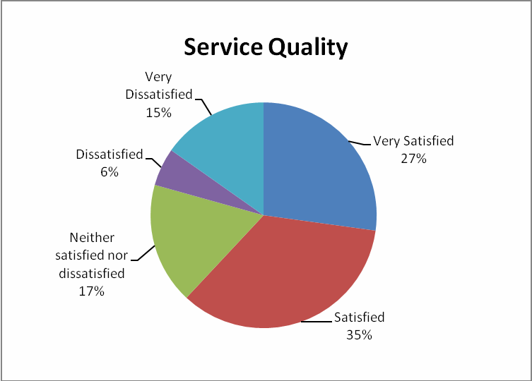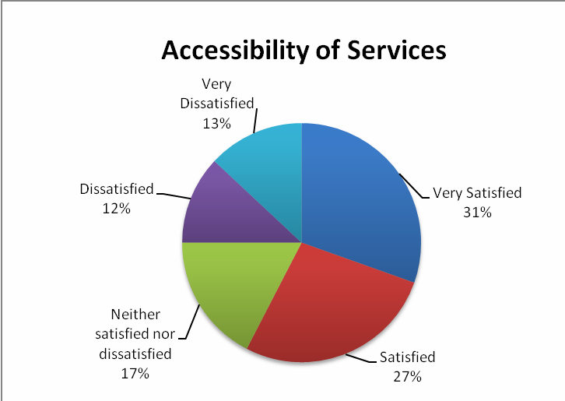

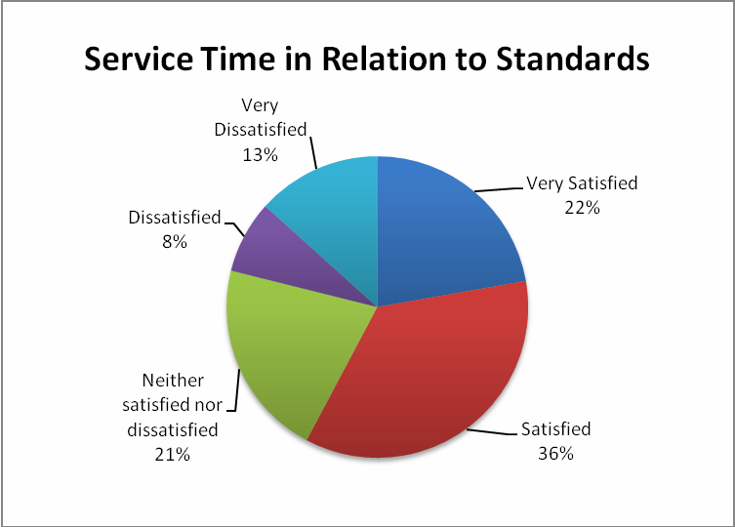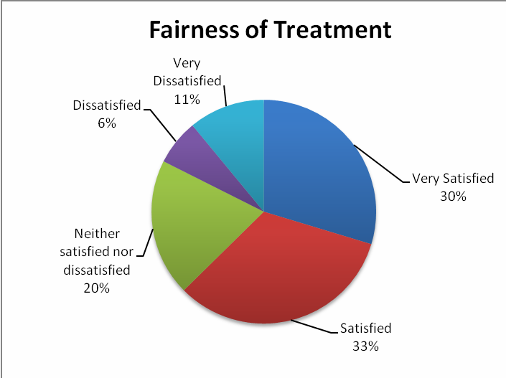

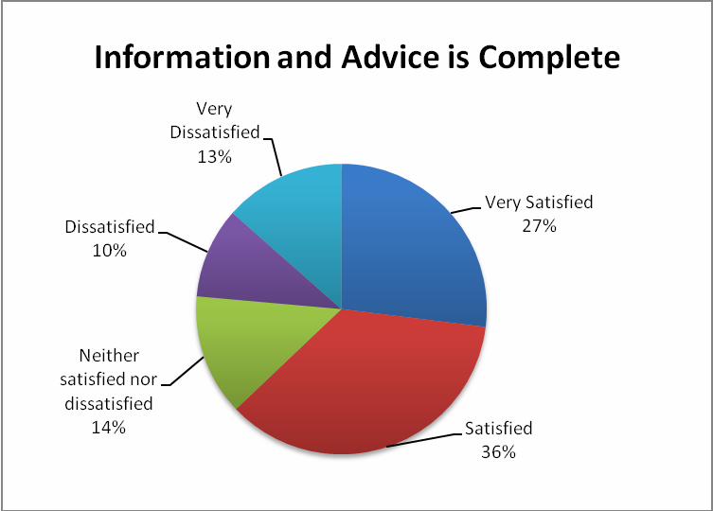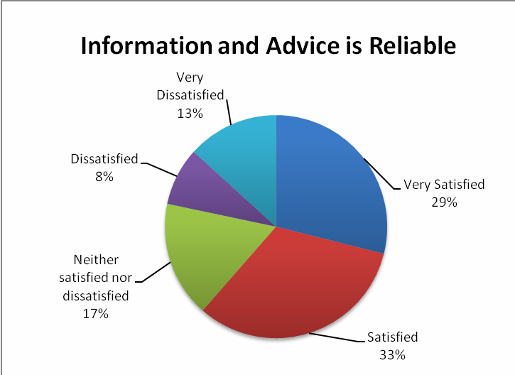

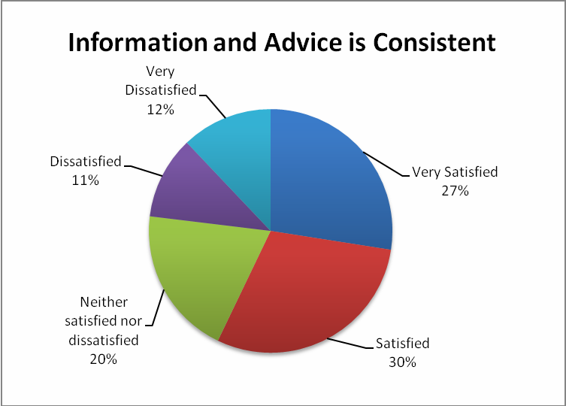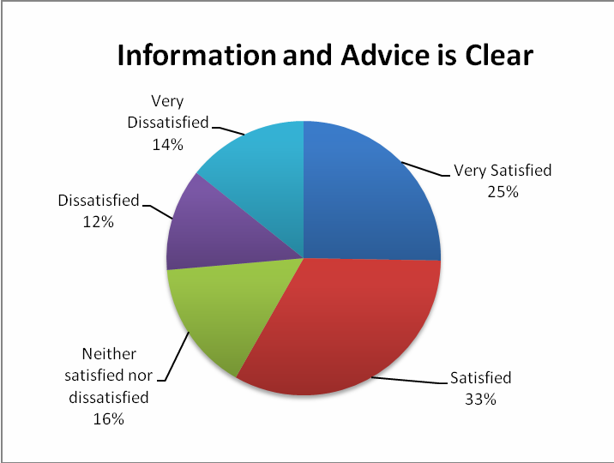

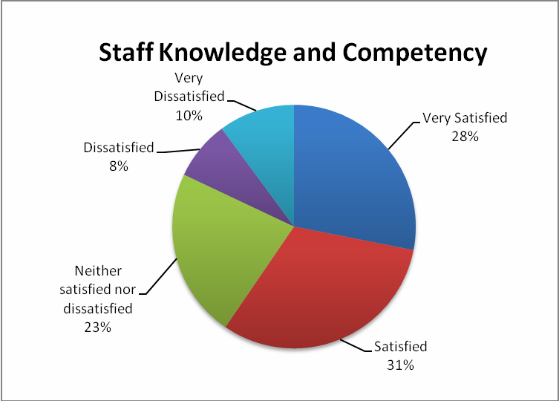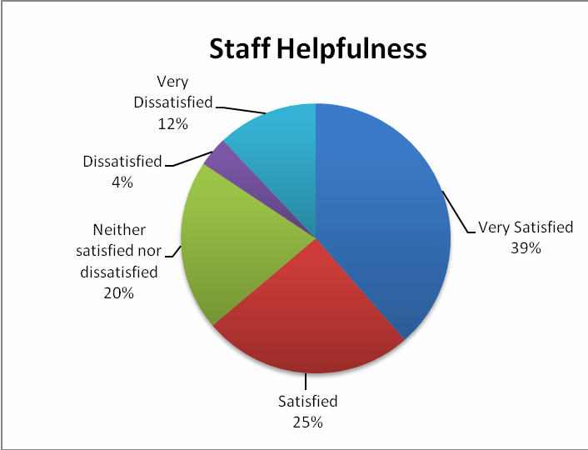

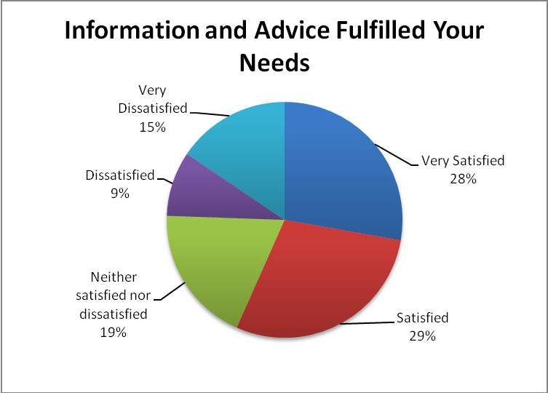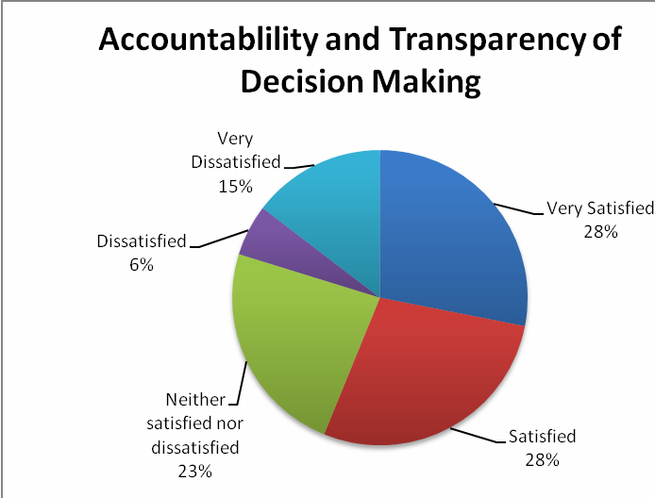

Website - level of satisfaction

