ACT REVENUE OFFICE
ACT Revenue Office

REVENUE CIRCULAR PTA027.1
Employment Agency Contracts: Chain of On-hire – Payroll Tax Act 2011
Issue Date: 18 September 2017
Status: Current – Effective 18 September 2017
Previous Circular: PTA027

Introduction
The employment agency provisions in Division 3.8 of Part 3 of the Payroll Tax Act 2011 (the Act) apply to an employment agency contract (whether formal or informal) where a person (the employment agent) procures the services of another person (service provider) to work for a client. Under such a contract, there is no agreement between the service provider and the client.

The diagram below depicts a common employment agency arrangement.

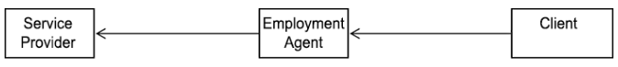

Under the employment agency provisions, the employment agent is taken to be the employer (section 38 of the Act) and the service provider is taken to be the employee (section 39 of the Act). Amounts paid or payable under the employment agency contract are taken to be wages (section 40 of the Act). Consequently, under section 41 of the Act, the employment agent is liable to pay payroll tax on the amounts taken to be wages.

This circular explains the payroll tax implications of an employment agency arrangement which involves multiple employment agents (‘chain of on-hire’).

Chain of on-hire
A ‘chain of on-hire’ occurs when an employment agent on-hires a service provider to another employment agent who in turn on-hires the service provider to its client. A strict application of the employment agency provisions on a ‘chain of on-hire’ would mean that both employment agents are liable for payroll tax on essentially the same employment agency arrangement.

To overcome this situation, in circumstances where there is a ‘chain of on-hire’, the employment agent closest to the ultimate client will be regarded by the Commissioner for ACT Revenue (the Commissioner) as the agent who is liable for payroll tax.

The following diagram shows an example of a ‘chain of on-hire’ arrangement:

The solid arrows indicate the first employment agency contract where Agent 1 procured the Service Provider for their client, Agent 2. The dashed arrows indicate the second employment agency contract where Agent 2 procured the Service Provider through Agent 1 for their client, Business 1. Under this chain of on-hire, Business 1 pays $100 to Agent 2. In turn, Agent 2 pays $75 to Agent 1, and Agent 1 then pays $50 to the Service Provider.

A strict application of the employment agency provisions would have the following outcome:

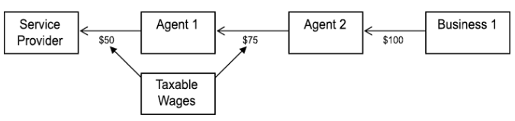

Agent 2 would be taken to be an employer under section 38 of the Act and the payment of $75 to Agent 1 would be taken to be wages under section 40 of the Act. Similarly, Agent 1 would also be deemed to be an employer and the payment of $50 to the Service Provider would be deemed as wages.

However, applying this circular, the Commissioner would only hold Agent 2 (who is the employment agent closest to the ultimate client) liable for payroll tax on $75 paid to Agent 1.

In order for Agent 1 and Agent 2 to know exactly what their respective payroll tax obligations will be, Agent 1 should require Agent 2 to complete the chain of on-hire declaration form available through the ACT Revenue Office website at www.revenue.act.gov.au.

The completion of this form will also overcome the situation where both Agent 1 and Agent 2 pay payroll tax on essentially the same employment agency arrangement.

In completing the declaration form, Agent 2 will confirm either it is:
- not liable for payroll tax; or
- liable for payroll tax and will pay payroll tax on the ‘wages’ paid to Agent 1.

If Agent 2 indicates on the declaration form that it is not liable for payroll tax (because its total wages is below the taxable threshold), Agent 1 would be liable for payroll tax on the $50 paid to the Service Provider. Upon receiving such a declaration, Agent 1 must ensure that payroll tax is paid on the payment they make to the Service Provider.

If there are more than 2 Agents, the declaration made between Agent 1 and Agent 2 can be passed down the line of on-hire accordingly.

If Agent 2 indicates on the declaration form that it will pay the payroll tax on the arrangement, the Commissioner will excuse Agent 1 from liability on the payment made to the Service Provider.

What if Agent 2 has declared incorrectly?
If Agent 2 has declared to Agent 1 that it is liable and will meet the payroll tax obligation under the employment agency arrangement, and the declaration was later found to have been made in error, the Commissioner will excuse Agent 1 from any retrospective liability if the Commissioner is satisfied that the incorrect declaration was:
- an honest mistake; and
- not made in an attempt to reduce or avoid a payroll tax liability.

Under these circumstances the Commissioner will generally assess Agent 2 for any arrears of payroll tax.

Anti-avoidance
If the Commissioner believes that the incorrect declaration was made, or the arrangement was set up, for the purposes of reducing or avoiding a payroll tax liability, the Commissioner may choose to impose payroll tax liability upon either Agent 1 or Agent 2 (section 42 of the Act).

Please note that revenue circulars do not have the force of law. Each decision made by the ACT Revenue Office is made on the merits of each individual case having regard to any relevant circular.

Criminal penalties
Giving false or misleading information is a serious offence. For details of the serious criminal offenses of making, giving or producing false or misleading statements, information or documents, see the Criminal Code 2002.

Signed

Kim Salisbury
Commissioner for ACT Revenue
18 September 2017

