2015 Client Survey
The ACT Revenue Office (ACTRO) conducted a survey from 20 October 2015 to 18 December 2015 as part of its commitment to maintaining and improving its customer service as well as its website.

The survey was available on the ACTRO website and as a hardcopy at the ACTRO Customer Services Counter. Regular clients at the ACT Revenue Office Customer Services Counter were encouraged to respond. On the website the survey was announced as a News item on 20 October2015. News items were sent to all Revenue Office website subscribers.

The survey was also advertised on the:
- Time to talk website at http://www.timetotalk.act.gov.au; and
- ACT Government portal as hot topic athttp://www.act.gov.au.

There were 78 online responses for 2015 compared to 75 online and 20 hardcopy for the 2014 survey.

Customer service-level of satisfaction
Customer Service | Satisfied or very satisfied
 | 2014 | 2015 | change
Service quality | 75% | 50% | 25%
Accessibility of services | 70% | 40% | 30%
Service time in relation to service standards | 73% | 51% | 22%
Fairness of treatment | 78% | 60% | 18%
Information and advice is complete | 73% | 50% | 23%
Information and advice is reliable | 74% | 58% | 16%
Information and advice is consistent | 71% | 60% | 11%
Information and advice is clear | 69% | 44% | 25%
Staff knowledge and competency | 77% | 63% | 14%
Staff helpfulness | 80% | 66% | 14%
Information and advice fulfilled your needs | 70% | 42% | 28%
Accountability and transparency of decision making | 74% | 44% | 30%

Website-level of satisfaction
Website | Agree or strongly agree
 | 2014 | 2015 | change
Most web pages use plain English and are easy to understand | 85% | 58% | 27%
For most webpage s the language used is suitable (eg.the reading level is easy to understand) | 85% | 74% | 11%
The detailed and technical information provided in circulars is suitable for your needs | 75% | 53% | 22%
Revenue Office forms are easy to understand and use | 75% | 47% | 28%
The rates postal address update form is useful | 86% | 63% | 23%
The calculators provide estimates of amounts payable. The calculators are useful | 88% | 69% | 19%
Navigation on the site is simple and easy to use | 75% | 28% | 47%
The site map is simple and easy to use | 75% | 55% | 20%
The search functions for news and circulars are useful | 69% | 40% | 29%
The subscription service is useful | 82% | 61% | 21%

Customer service level of satisfaction charts

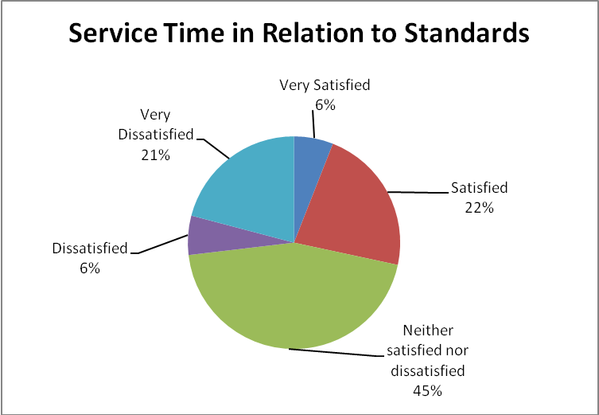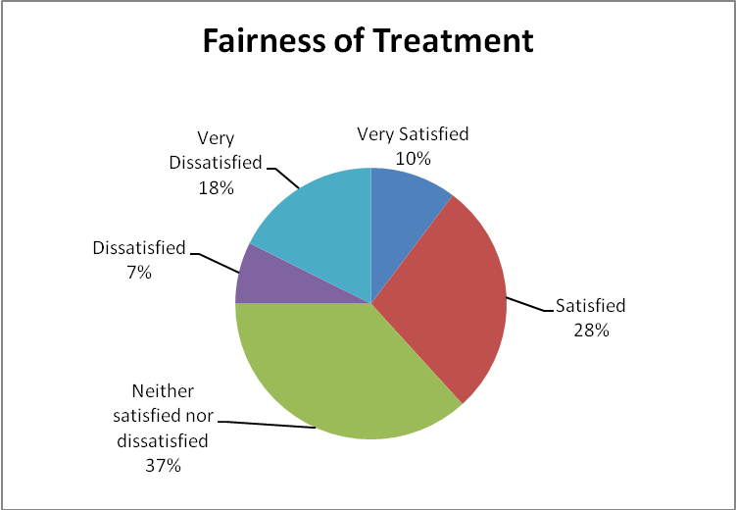

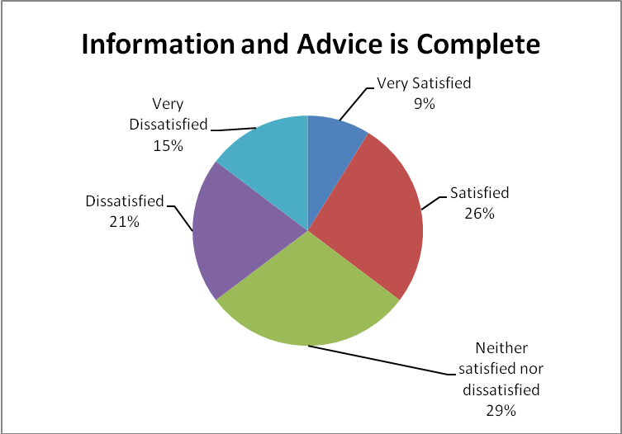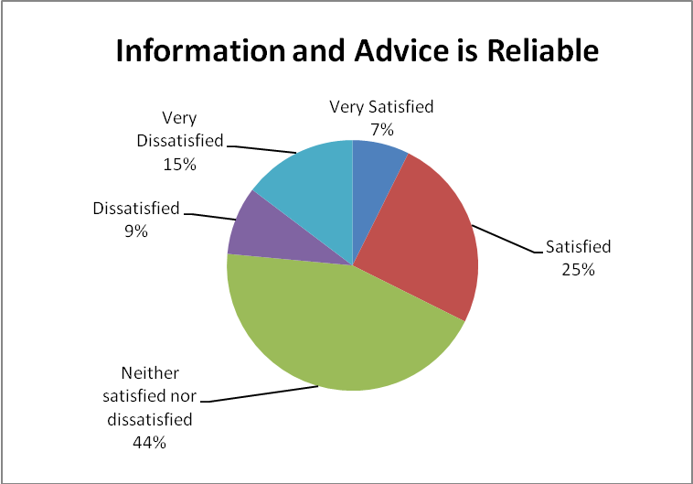

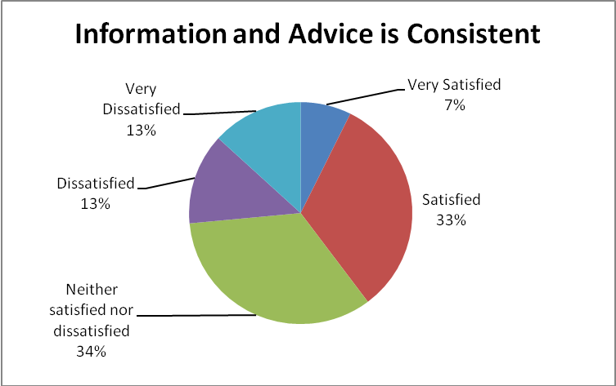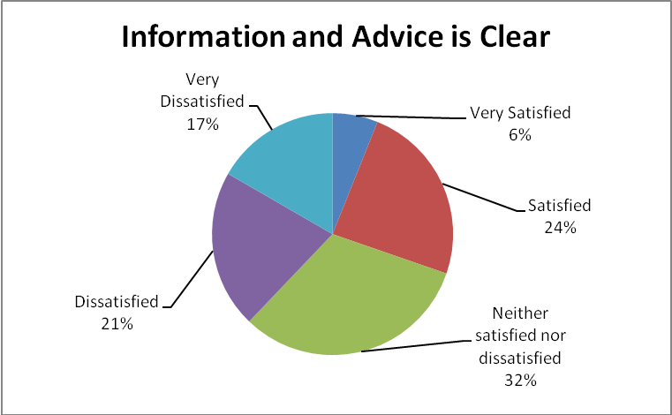

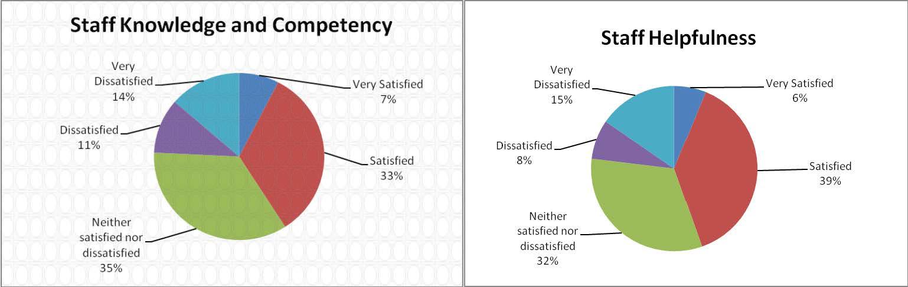

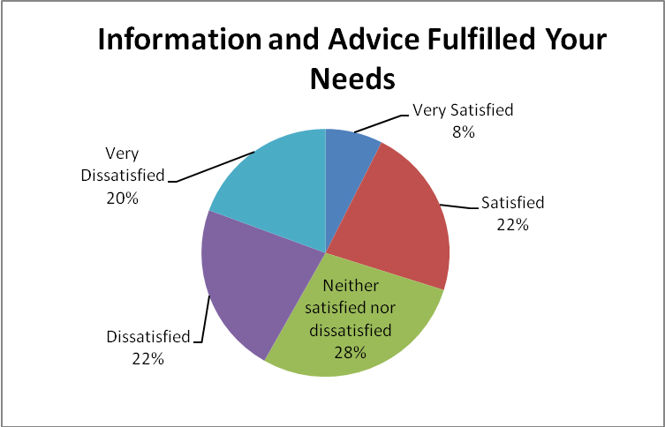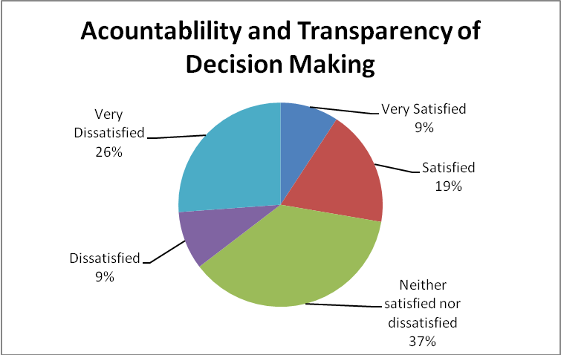

Website - level of satisfaction

